How to Interpret the Flow by Major Progression Reports

Overview and Purpose

The Flow by Major Progression Report provides trend data by entering major within each college/school detailing their status within the university from their entering fall semester to succeeding years along with their major in those succeeding years. The report is intended to answer the following questions:

How many students stay in their entering major or leave their entering majors after one year, etc.?
If they do leave, which colleges/majors within the university do they go to from their entering major?
What degrees do they ultimately graduate with?

Report Details
When the Flow by Major Progression Report has run, the resulting excel output includes three worksheets – the College Summary, a Continuing Detail, and a Graduated Detail. The College Summary provides aggregated flow status information for each major according to the following categories:

- Dismissed
- Dropped Out
- Cont. - Same Major
- Cont. in Another Major – Same College
- Cont. – Another College
- Grad. in Same Instructional Program Area
- Grad. in Another Instructional Program Area – Same College
- Graduated – Another College

The Continuing and Graduated Detail worksheets provides detailed major/program information. Definitions of these report data are provided in Appendix A.

Flow by Major Progression Report Sections

College Summary
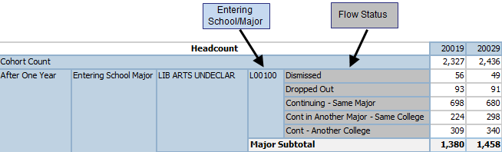

Continuing Detail
Entering School/Major (in blue) – Ending (Flow) School/Major in (gray)
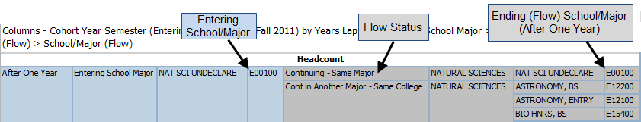

Graduated Detail
Entering School/Major (in blue) – Degree School/Major (in gray)
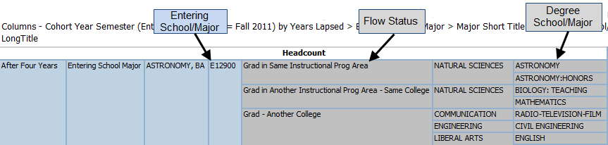

APPENDIX A - DEFINITIONS

Entering Year Semester (Cohort Year Semester) – Student entering year/semester – Ex. Fall 2010 entering freshman cohort, Fall 2011 entering freshman cohort, etc.

20109 = Fall 2010
20119 = Fall 2011

Students included are full-time (enrolled for 12 or more hours) and in a degree-seeking program. First-time in college fall entrants in this report include those students enrolled in college for the first time in the fall semester, or for the first time in the prior summer semester and continuing into the fall.

Years Lapsed (After One Year, After Two Years, etc.) - the cohort’s progression from the student’s entering fall semester to a succeeding fall semester.

Entering College/School – the student’s entering college/school

Entering School/Major or School/Major (Entering) – the student’s entering school/major. The first digit represents the College/School. The last 5digits are the major code (EX. L31500 – L = Liberal Arts; 31500 = English).

Ending (Flow) School/Major – the student’s major to the succeeding fall semester to which the cohort’s progression is being tracked (i.e. the student’s school/major after one year, after two years, etc.)

Degree School/Major – the student’s first degree awarded.

Gender (Entering) – the gender, Male or Female, as reported by the student for their entering semester. For consistency purposes across years, any subsequent changes to the student’s record are not included in this cube/report.

Ethnicity/Race (Entering) - as reported by the student for their entering semester. An unknown ethnicity/race indicates that a student opted not to report. Foreign students (non-resident aliens) have not been assigned to their respective ethnic/race categories. For consistency purposes across years, any subsequent changes to the student’s record are not included in this Cube. Starting in Fall 2010, the report was modified because of the federal ethnicity/race code changes.

Residency (Entering) - the current residence as reported by the student for their entering semester. Original and current residence is the same for first time students. For consistency purposes across years, any subsequent changes to the student’s record are not included in this cube/report.

Dismissed - scholastic dismissal from the University (after having been placed on scholastic probation)
Dropped Out - not enrolled on census date. These students left the University for personal, financial, academic, or other reasons; students on scholastic probation who dropped out before being dismissed are included in this group.

Continuing - Same Major - students still enrolled in the college/school and major originally entered.

Continuing in Another Major- Same College – students still enrolled in the college/school they originally entered in but not in the same major.

Continuing - Another College (Out-Migration) – still enrolled in any UT-Austin college or school but no longer in their entering college/school.

Graduated in Same Instructional Program Area – students who graduated from the same college/school and instructional program area (Classification of Instructional Programs or CIP) originally entered into (Entering Major CIP equals Degree Program CIP).

Graduated in Another Instructional Program – Same College – students who graduated from the same college/school they originally entered but not from the same instructional program (Classification of Instructional Programs or CIP) (Entering Major CIP does not equal Degree Program CIP).

In the case of an instructional program code that has been replaced/deleted, the student’s entering major CIP code may not match the replacement instructional program code resulting in their entering school/major CIP not matching the degree program CIP even though the student’s major/degree program seemingly has not changed.

EX. For an entering major of Czech (L29900) in fall 2001, the major CIP had been CIP 16.0403.0101- Slavic Languages and Literatures (Other than Russian) but that has been subsequently deleted as an available program. The current Czech program would be 16.0406.0001- Czech Language and Literature so in that case the entering major CIP would not match the degree CIP

Graduated - Another College (Out-Migration) – graduated from another UT-Austin college/school; not the college/school they originally entered.

